1a

def test_nhi_phan(a):

    if(a == '0000' or a== '0001' or a == '0010' or a== '0011' or a == '0100' or a== '0101' or

    a == '0110' or a== '0111' or  a == '1001'):

        return True

    else:

        return False

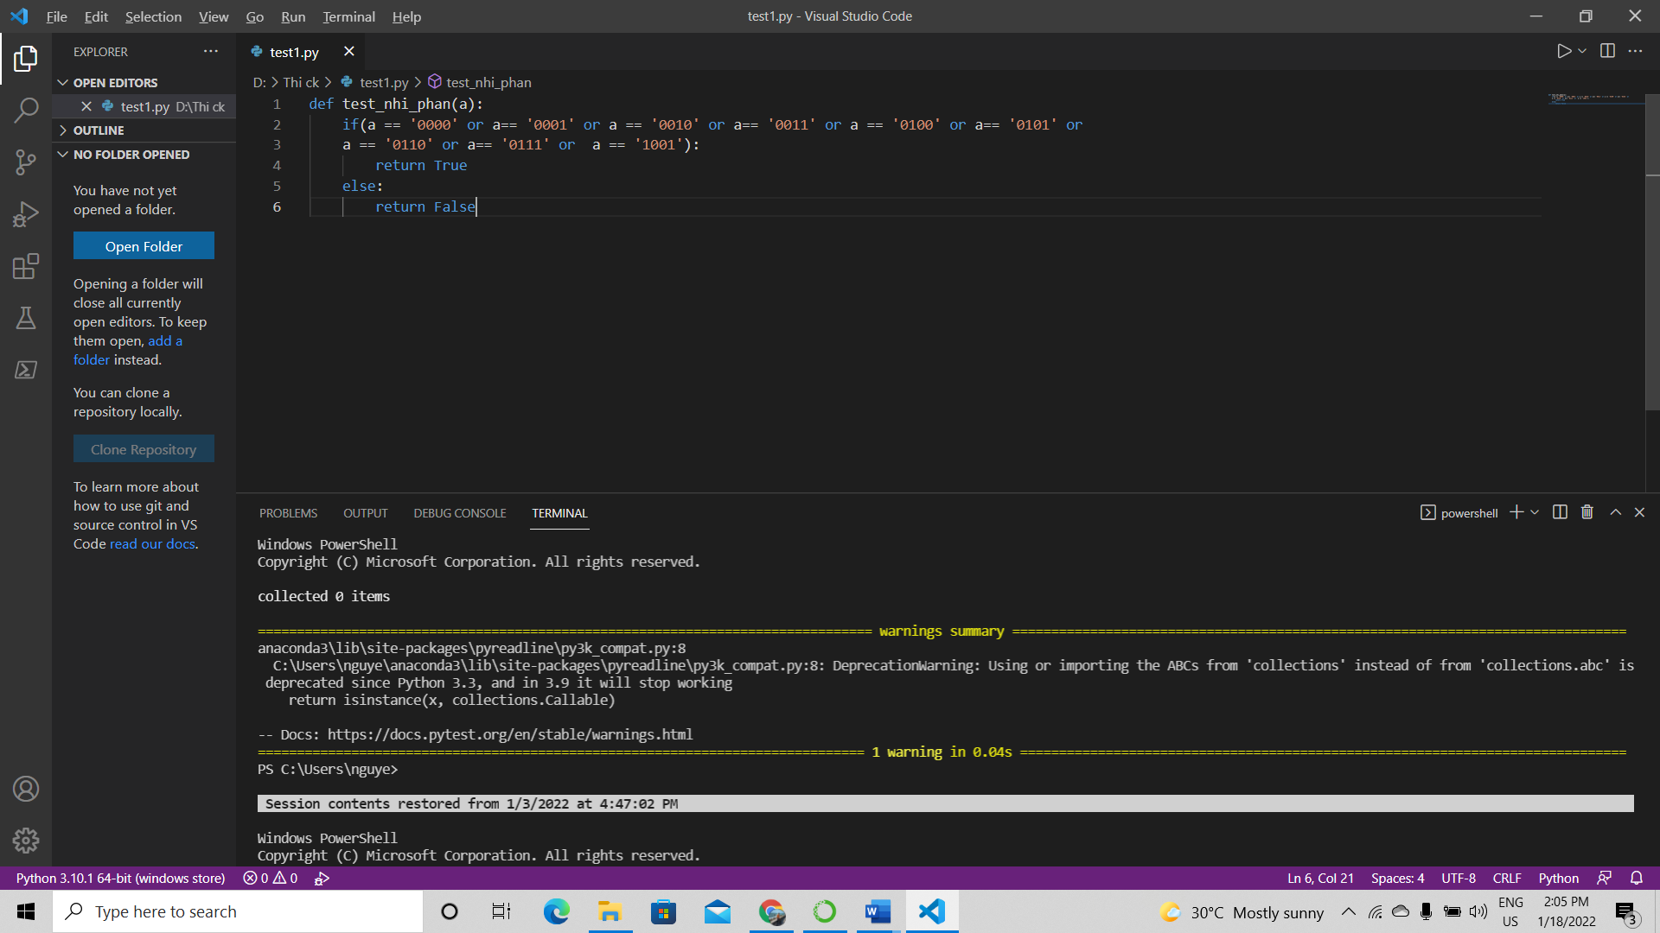

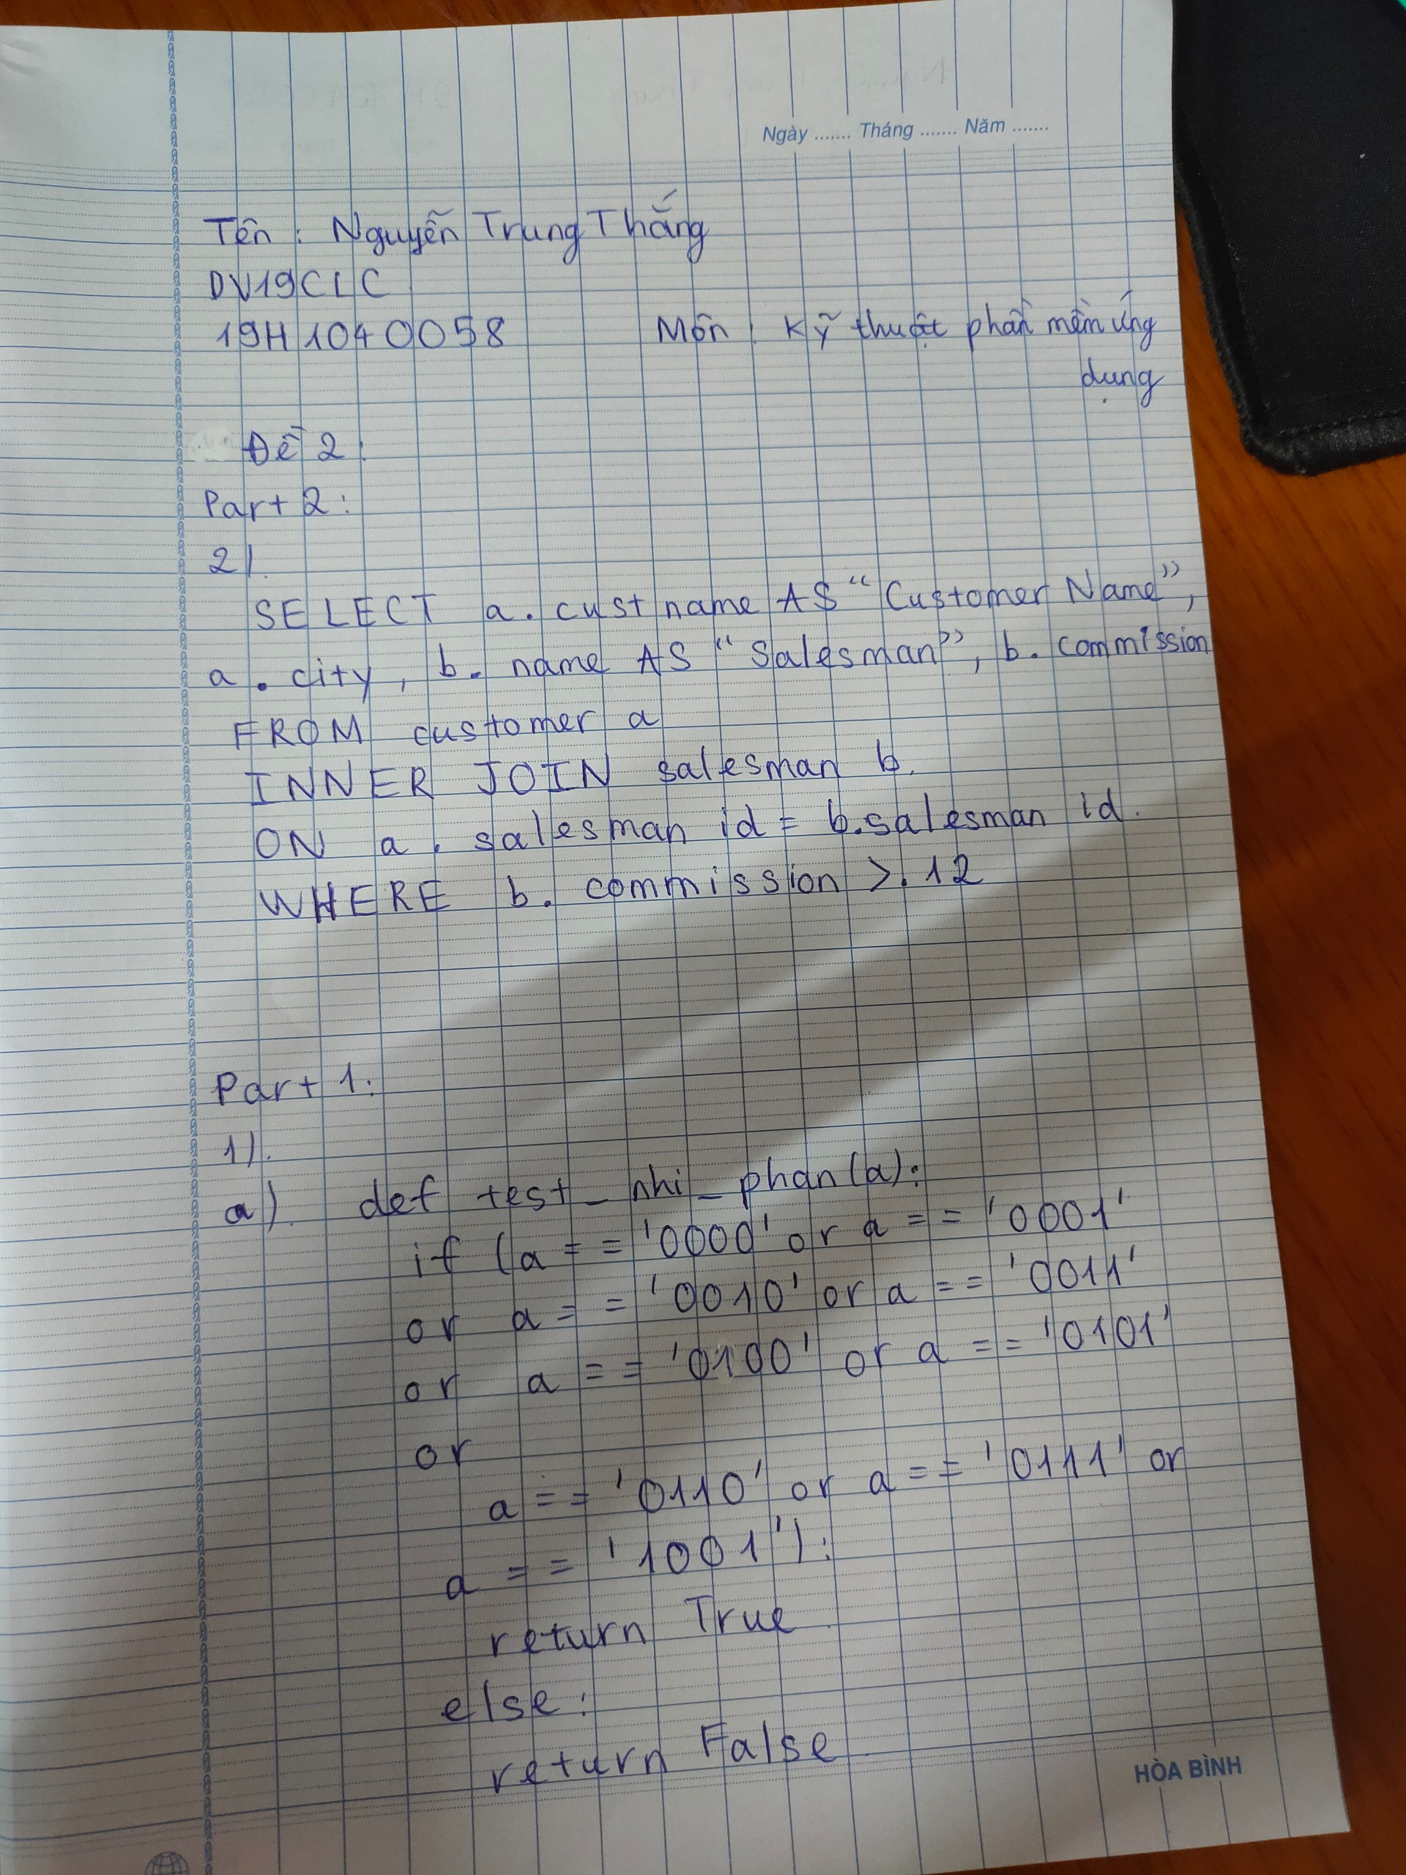

1b

import math

class Real_Number:

    def __init__(self, real_number):

        self.real_number = real_number

    def module(self):

        return abs(self.real_number)

class Complex_Number(Real_Number):

    def __init__(self, real_number, image_number):

        super().__init__(real_number)

        self.image_number = image_number

    def module(self):

        return math.sqrt((self.real_number * 2) + (self.image_number * 2))

num = Complex_Number(10, 3)

print(num.module())

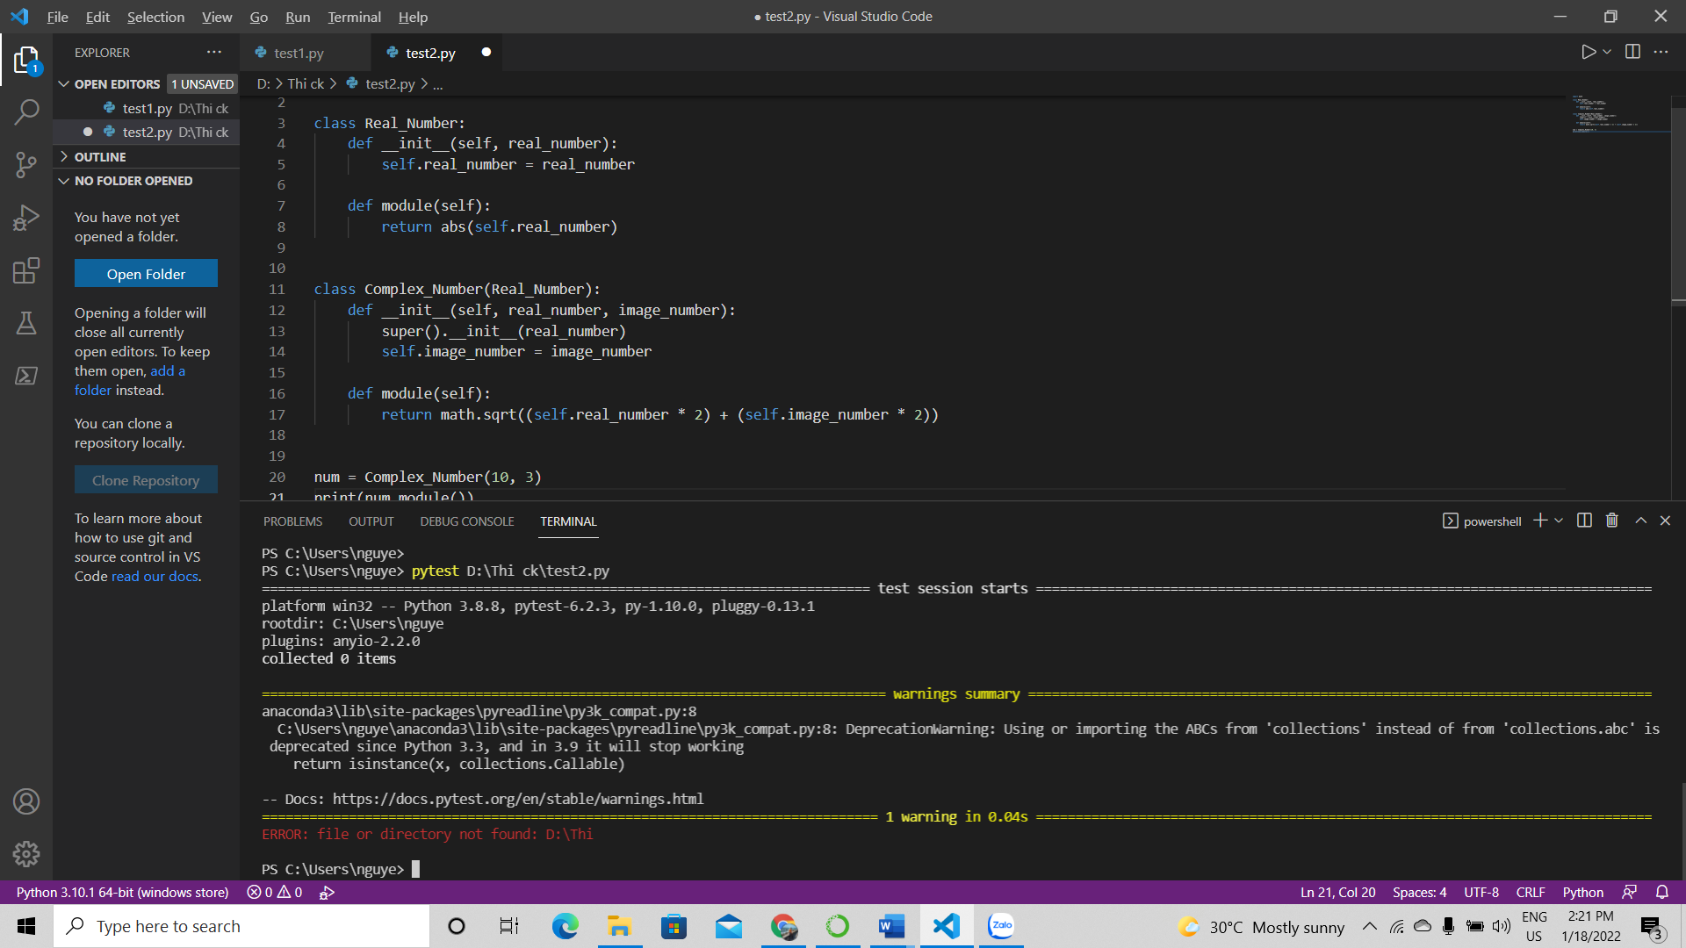

Part2

2a.

SELECT a.cust_name AS "city",

a.city, b.commission

FROM customer a

INNER JOIN salesman b

ON a.salesman_id=b.salesman_id

WHERE b.commission>.10;

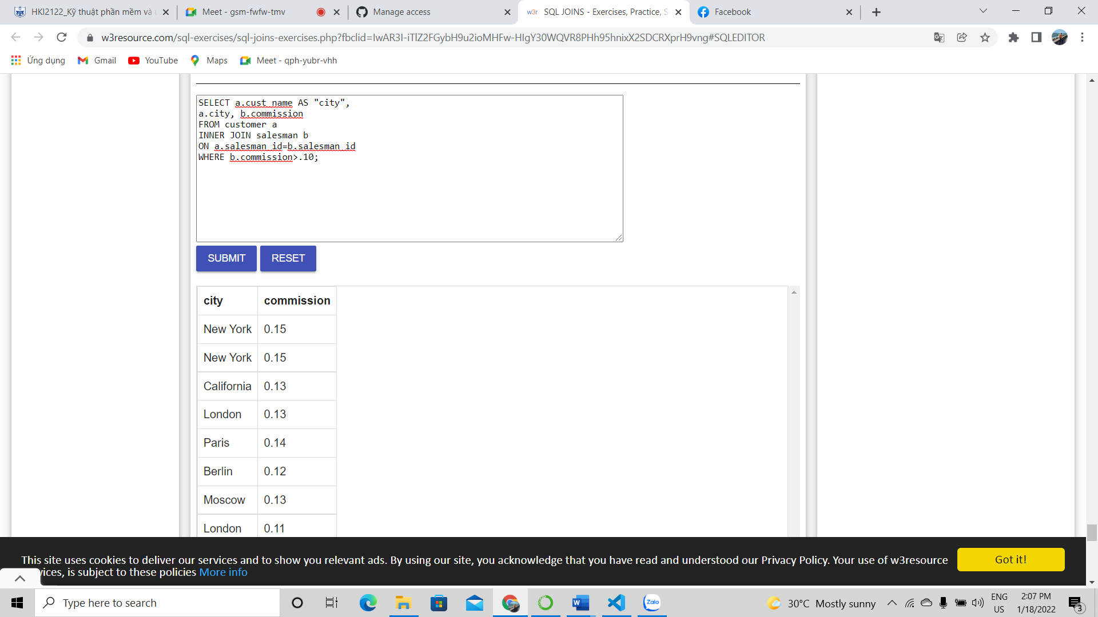

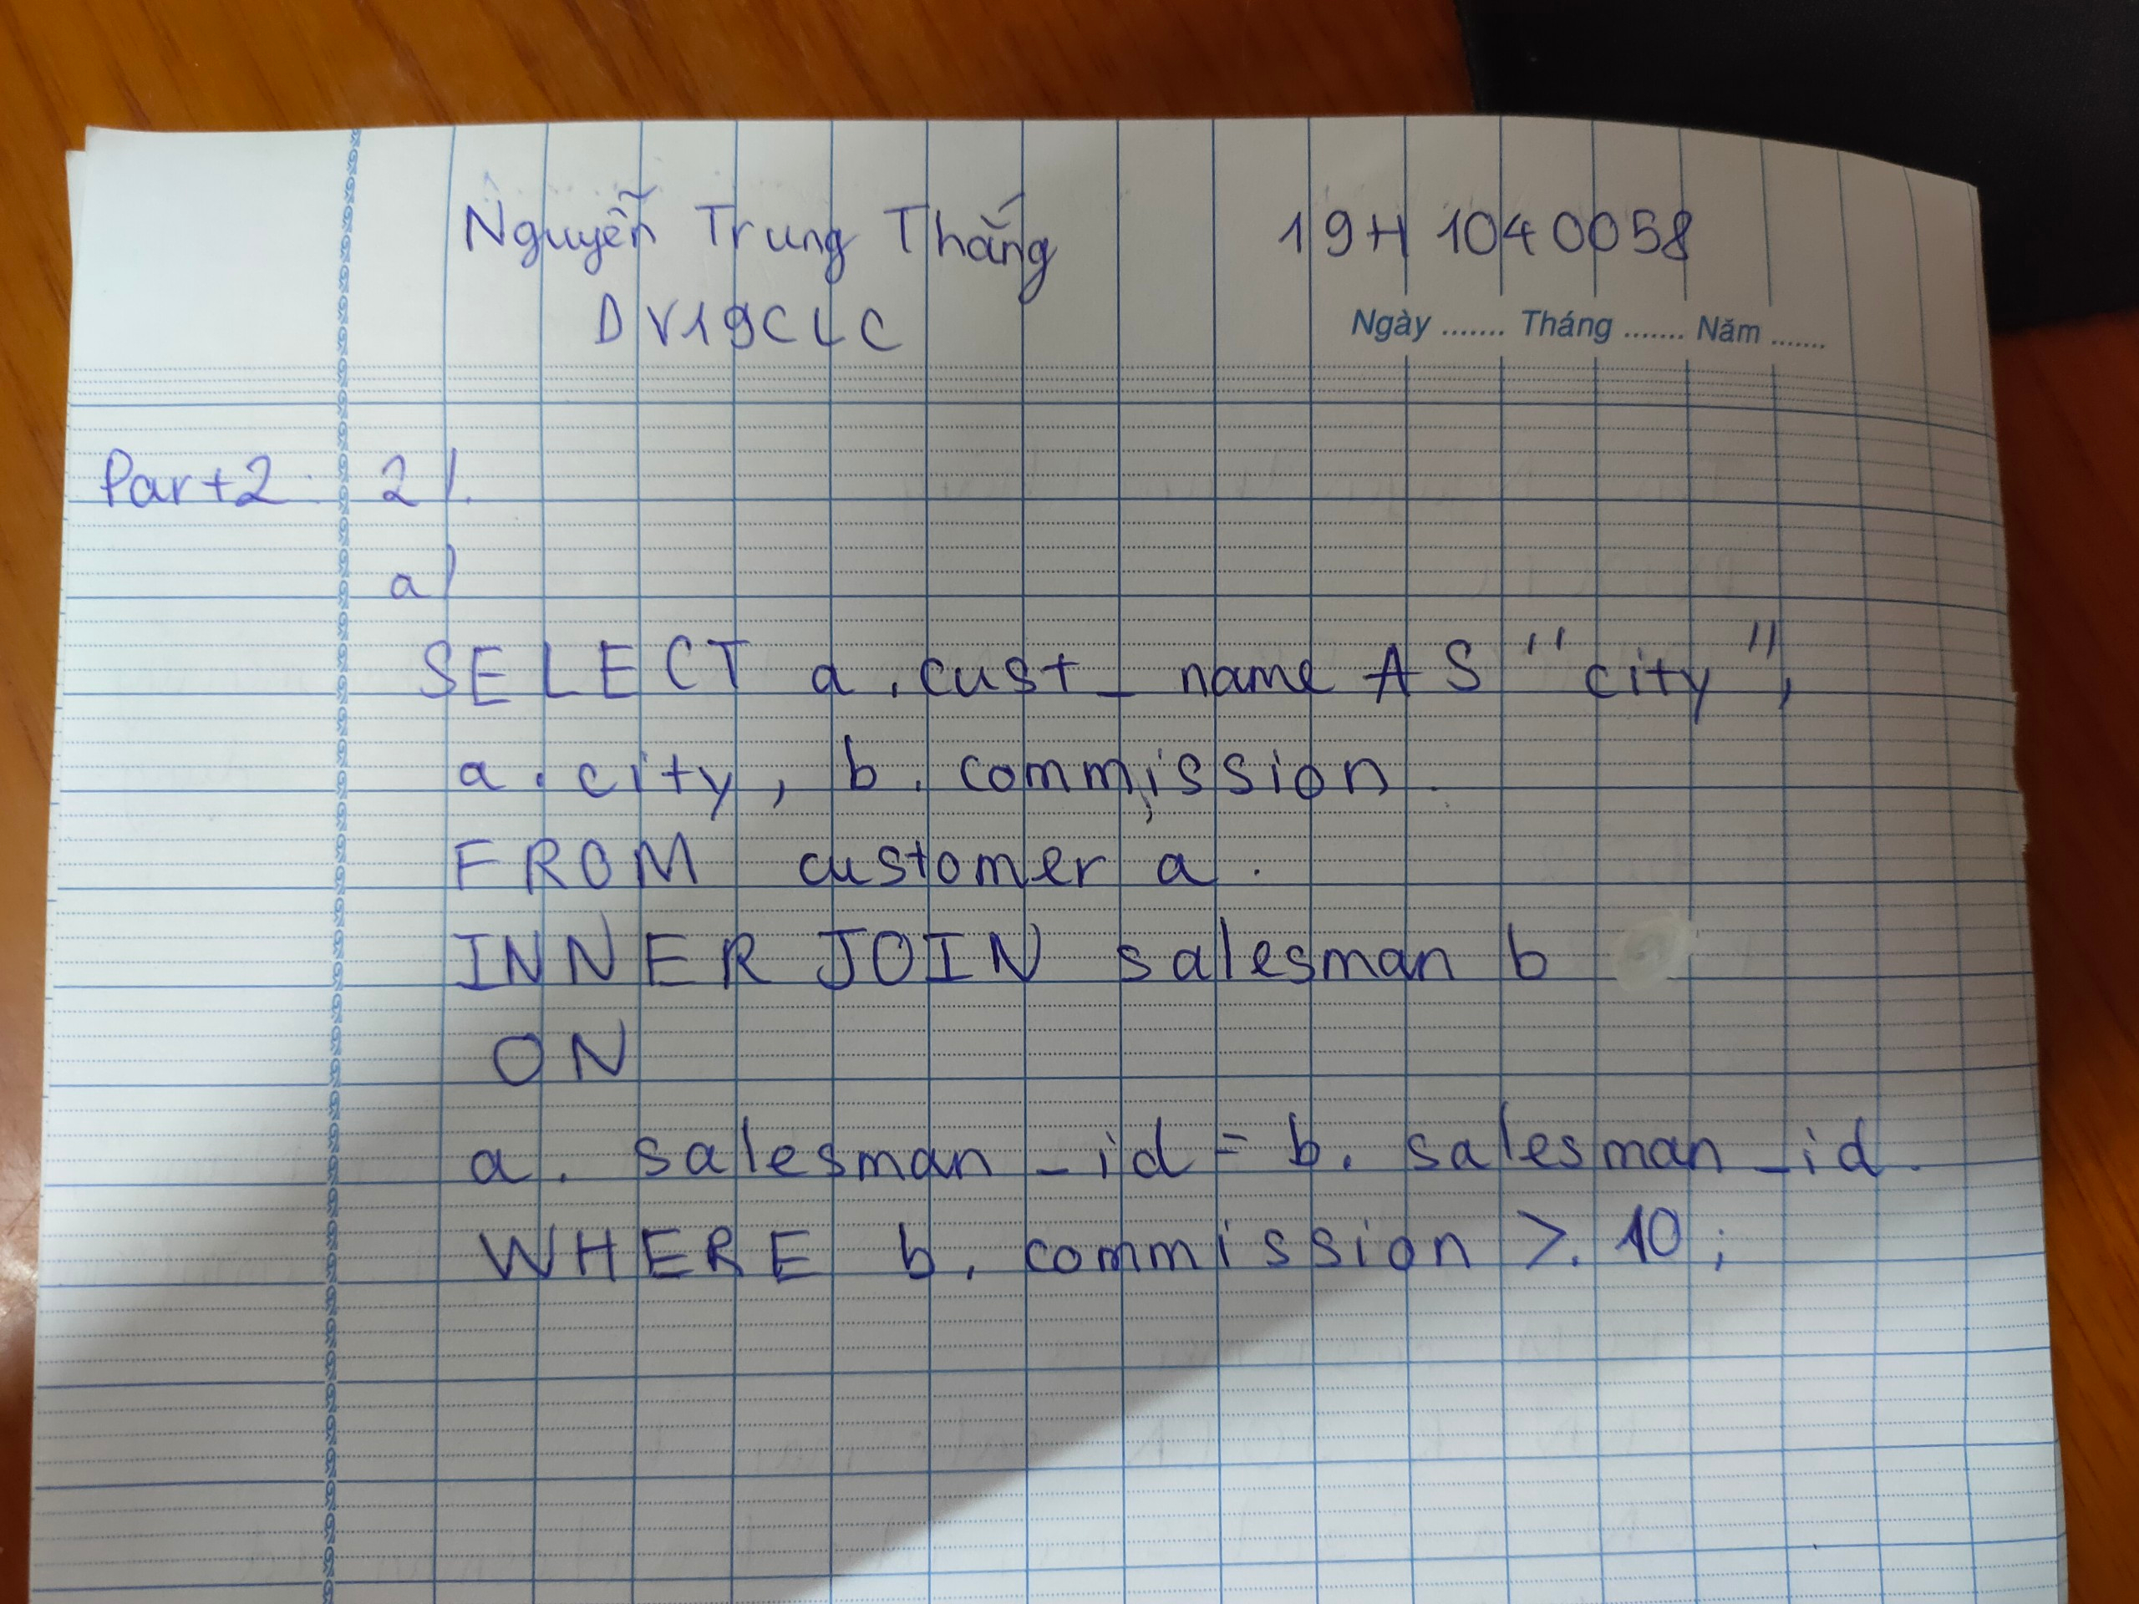

2b.

SELECT a.cust_name AS "Customer Name",

a.city, b.name AS "Salesman", b.commission

FROM customer a

INNER JOIN salesman b

ON a.salesman_id=b.salesman_id

WHERE b.commission>.12;

